**Sitecore PowerShell Extensions Installation Hangs on Spinning Wheel – Sitecore 8.2**

[Sitecore PowerShell Extensions](https://doc.sitecorepowershell.com/) is a powerful Sitecore development tool to manage Sitecore contents, create automation jobs and do a tons of cool stuff. It brings the PowerShell scripting capabilities to deliver Sitecore solutions faster. It also has a lot of out of box tools that doesn’t require PowerShell scripting skills.

It is created by the community developers and can be installed from the [market place](https://marketplace.sitecore.net/en/Modules/Sitecore_PowerShell_console.aspx).

When you try to install the tool, you might encounter the package installation hanging on the spinning wheel.

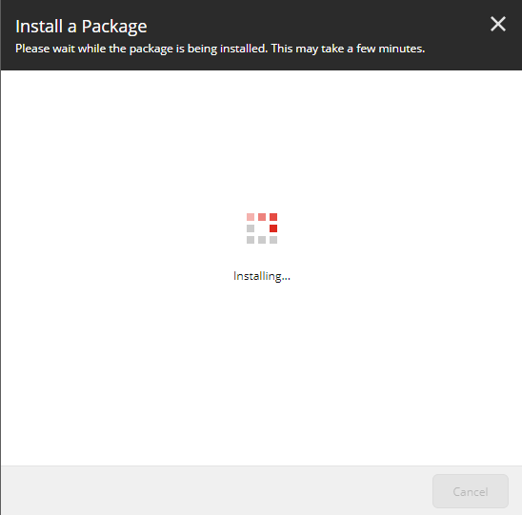

**Solutions**

Simple! You need to run your MongoDB. Without connection to MongoDB, the installation hangs.

If you haven’t installed MongoDB, [here](https://docs.mongodb.com/v3.2/tutorial/install-mongodb-on-windows/) is the installation instruction. For local machine, I recommend you to run MongoDB as a service.

Running MongoDB as Windows service

1. **Setting up folders**

When you install MongoDB to windows, you will create a db folder as C:/data/db. In the data folder, create config and logs folders.

[cc lang="text" tab_size="4" lines="-1" theme="mac-classic" line_numbers="false"]

- C:

- data

- db

- config

- logs

[/cc]

1. **Adding config file**

In the data folder, create a config file as mongod.cfg and add the lines below.

[cc lang="text" tab_size="4" lines="-1" theme="mac-classic" line_numbers="false"]

logpath=C:\data\logs\mongo.log

dbpath=C:\data\db

[/cc]

1. **Setting up Mongo bin path**

Add C:\Program Files\MongoDB\Server\3.6\bin to Environment Variable. This will enable you to run mongo commands from cmd.

1. **Install MongoDB to Windows service**

Make sure that your MongoDB server is stopped. Run the command below.

[cc lang="text" tab_size="4" lines="-1" theme="mac-classic" line_numbers="false"]

mongod --config "C:\data\config\mongod.cfg" --install

[/cc]

1. **Check the service**

You will see the MongoDB Service running.

